Machine Learning CS 6140
Miles Benjamin
Assignment 1

1)

2) Discrete and Continuous Distributions: Write down the formula of the probability den-
sity/mass functions of random variable X.
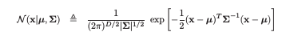
1. Multivariate Gaussian Distribution

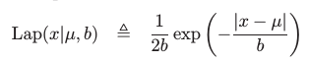
2. Laplace Distribution

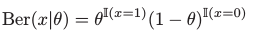
3. Bernoulli Distribution

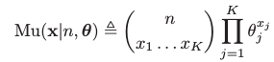
4. Multinomial Distribution

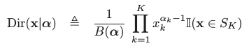
5. Dirichlet Distribution

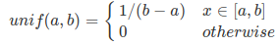
6. Uniform Distribution

7. Exponential Distribution

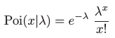
8. Poisson Distribution

3) Positive-Definite Matrices:
1. A is positive semi-definite because any matrix multiplied by it’s transpose is positive semi-definite as along as all of it’s values are real. Since all of B’s values are real, BtB is positive semi-definite.
2. A is positive semi-definite because it’s eigenvalues are [8- √19, 0, 8+ √19] all of which are positive.
3.

